

Automation Technology 1

Lab 4: Eir Intruder Alarm
Lecturer: Eoin Byrne
Submission Date: To be confirmed during the semester

Section 1 – Introduction to Simple Ladder Diagrams

Abstract:
To familiarize the student and gain confidence in constructing a ladder diagram with a given process. Students to reproduce the diagram given and test the process by downloading to the PLC and conducting monitor mode to test all relevant functions. Finally the Students must fully hardwire the automation problem and ensure full functionality.
.

Objective:

1:To Merge both timers and counters into an alarm system to demonstrate to the student applications where these functions are employed in PLC Programming.

2: Physical hardwiring of the system using basic wiring diagrams.

Automation Problem:

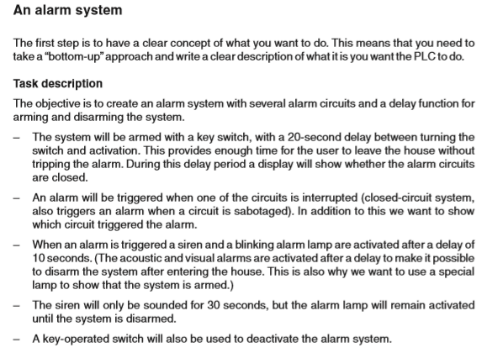

Address Table of I/0:

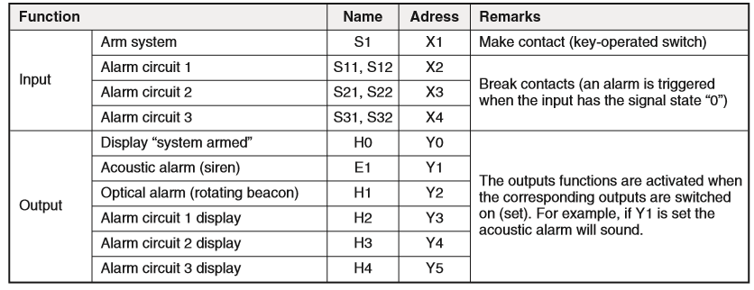

Ladder Diagram Provided:

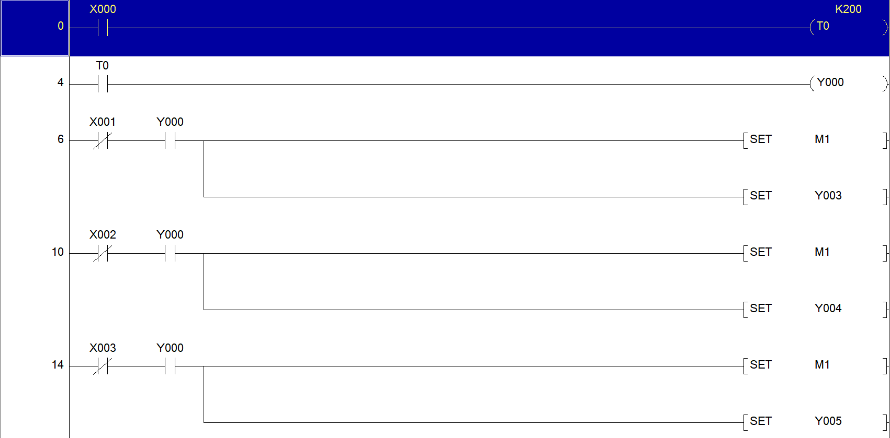
`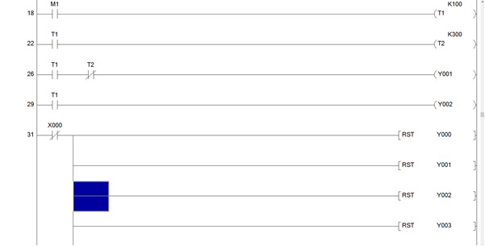
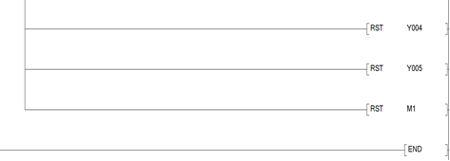

Instructions:

1: Construct the ladder diagram with Labels showing clarity within the PLC program as above in GX Works 2 and download to PLC. Test for complete functionality of the alarm system using the Online Simulator.
(10 Marks)

2: Screen Shot of completed ladder diagram under a functional test. Explaining clearly what is occurring in each rung of the ladder logic. Alternation of the Ladder diagram to enable external Siren to be connected via the PLC Test Kit. Also the beacon must also flash on the test Kit (Hint 0.5s On 0.5s off)
(30 Marks)
3:Hard wiring Sketch of all inputs and outputs wired from the PLC to the desired inputs and outputs.
(30 Marks)
4:Physical Hard wiring of the complete Scenario with Demonstration on circuit built.
(20 Marks)
5:Conclusion (10 Marks)

